FoodPantry

Business Requirements Document

Project: FoodPantry

Author(s): Aleksander Kamenev, Christus Martey, Yash Kawade, Yashraj Bhandare, Pratikkumar Chaudhari, Preethi Nimmakayala

Table of Contents

**Project Overview (Yash Kawade)** **3**

**Document Information(Pratikkumar)** **3**

2.1 Audience 3

**Business Opportunity(Aleks Kamenev)** **3**

3.1 Project Overview and Background 3

3.2 Current State Analysis 4

3.3 Future State Objectives 4

3.4 Business Domain Model and Stakeholders 5

**Business Requirements(Aleks, Christus)** **8**

4.1 Details of Business Requirements 9

**Non-Functional Requirements (Pratik, Preethi)** **11**

**External Data Feeds (Yash, Yashraj)** **12**

**Business Risks(Yash Kawade)** **12**

# **Project Overview (Yash Kawade)**

This document describes the business/user requirements for FoodPantry that will provide the basis for the following project activities:

* Introducing business/user requirements
* Creating test plans and test specifications
* Identifying stakeholders
* Devising solutions to project tasks
* Produce an application that will allow users to help the community by providing their assistance in multiple ways, be it by donating food, volunteering their time, helping NGOs or simply by donating money to the platform.
* Determining a time frame for the project’s completion
* Assessing the degree to which the project succeeded

# **Document Information(Pratikkumar)**

## 2.1 Audience

| Name | Business Group | Role |
| --- | --- | --- |
| Support team | Account Management | Internal entity |
| Donor, Receivers and Couriers | Support team | Web Application User |
| Payment merchants and financial institutions | Finance Management | Partner/Supplier |
| Ads Agency | Advertisement Management | Partner/Supplier |
| Restaurants and Food retailers | Donor Recruitment | Partner/Web Application User |

# **Business Opportunity(Aleks Kamenev)**

## 3.1 Project Overview and Background

The project is rooted in the simple and honest notion of helping those in need and giving back to the community. The purpose of this project is to develop a cross platform web application which will allow users to donate food, volunteer their time and be able to benefit from the kindness of others. These three aspects of the project's mission translate to the three different types of user accounts. More details about the user types can be found in section ***4 Business Requirements*** of this. Our goal is to produce an intuitive, responsive and user-friendly application which will take away any unnecessary complexity and stress out of the process of donating food to people in need. The platform will allow users to list food items for donation, accept available items as delivery couriers and share with other users what their current food donation needs are.

## 3.2 Current State Analysis

In today's ever more interconnected and technology reliant world the simple action of giving and helping our fellow humans has fated into the background. While food drives, shelters and non profit organizations focused on food donations exist they are often considered a higher level of commitment and require more effort and engagement. The average city dweller wants to help those in need of help but is either too busy, too tired or simply doesn’t know the best way to do so. This is where FoodPantry comes in. By abstracting the complexity away from the end user and providing a smoothly flowing framework to handle the organizational and logistic overhead we allow people to focus only on the important task of helping. Users can simply log in and with the press of a few buttons either offer up food or volunteer their time as couriers.

The tech stack of the project is planted to utilize the following technologies and programming languages: JavaScript, HTML, CSS, Node.JS, React JS, Ionic, Github (version control), (MongoDB of Firebase) and PostGres or Oracle (for relational database needs)

The project is well into the planning stage and development of an initial demo prototype is under construction.

## 3.3 Future State Objectives

The objective is to develop, launch and provide long term support to a cross platform web application which will make donating food and volunteering time as easy as it can possibly be. Roooted in a strong sense of social justice and a firm belief in the inherent kindness of the human spirit we believe that all people need in order to do good is a place where they can come together and do so as a community.

The application will offer an easy and intuitive interface. Users will be able to quickly and easily offer up food items for donation, claim items to act as couriers for and state their current news in terms of food donations.

## 

## 3.4 Business Domain Model and Stakeholders

| Stakeholders |
| --- |
| Map/navigation service company |
| Food donor (restaurants & retailers) |
| Advertising media companies |
| Businesses owning ad space on our platform |
| Bank |
| Payment merchants - (Mastercard, Visa, AmericanExpress, Paypal) |
| NGOs - registered as couriers |
| Volunteers - registered as couriers |
| People in need of food donations - registered as receivers |

**FoodPantry B**usiness **R**elationship **M**ap

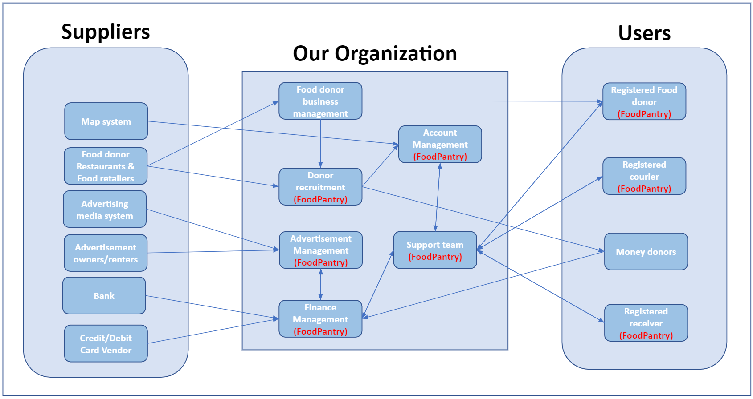

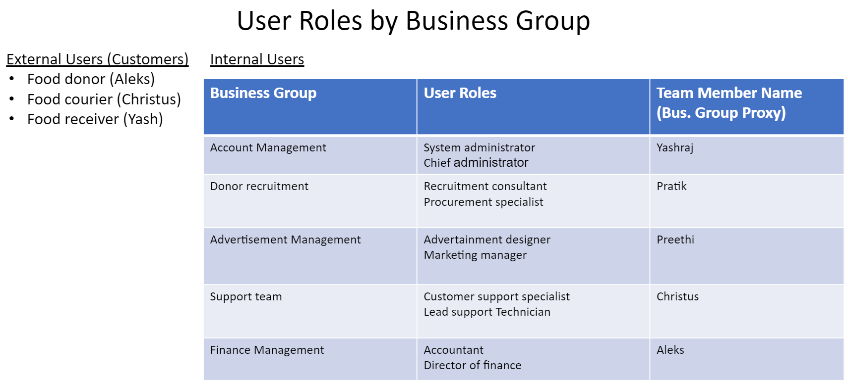

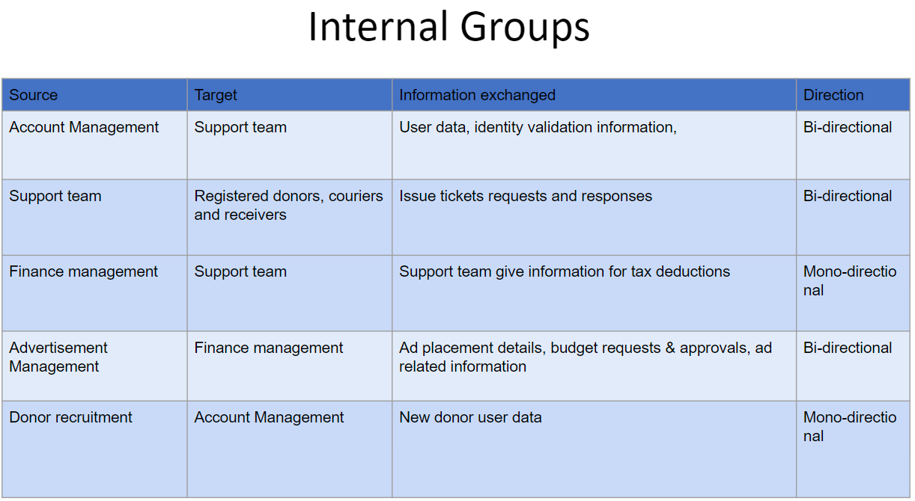

The business relationship map above and supportive tables showcase the interactions and relations between our organization and our suppliers and users.

* **Suppliers**
  + Map system
    - Powers the in app map and functionality for navigation to package pick-up and drop-off locations.
  + Food donors (Restaurants & Food retailers)
    - Potential businesses to be approached and attracted to the platform as donor class users.
  + Advertising gmedia system
    - All platforms which we use to promote and advertise our business.
  + Advertisement owners/renters
    - Businesses and individuals who purchase advertising space on our platform.
  + Bank
    - Institution to handle funds safekeeping.
  + Credit/Debit Card vendor
    - Payment management businesses which handle card based transactions of funds. Primarily used by our platform to facilitate donations to the FoodPantry itself.
* **Our Organization**
  + Food donor business management
    - Internal management structures of businesses listed as food donors on our app or ones that are being groomed to join.
  + Account management
    - Internal group which deals with all user account related handling.
  + Donor recruitment
    - Internal group which focuses on two primary tasks:
      1. Attracting new donor class users.
      2. Securing continuing donations to the platform itself through fundraising and other such techniques.
  + Advertisement Management
    - Internal group focused on promoting the platform through ad campaigns. Also handles organization and logistics related to the sale of advertising space to third parties on the FoodPantry network.
  + Support team
    - Provides technical support to users.
  + Finance management
    - Responsible for the following key tasks:
      1. Company wide budget creation.
      2. Approval of departmental budgets.
      3. Book keeping and compliance with tax law.
      4. Outgoing and incoming movement of funds.
* **Users**
  + Food donor
    - Users donate food by listing the items on the platform and making it available for couriers.
  + Food couriers
    - Users which volunteer their time and act as a middle man between the donors and receivers.
  + Food receivers
    - People in need of food donations who enter the rooter of potential end points for a food donation.

# **Business Requirements(Aleks, Christus)**

The application FoodPantry has three distinct main user categories. They are as follows: food donors, couriers, and receivers. Based on the type of user account selected at the time of registration the information requested and the registration process itself will vary. All users will share the use case of authentication. Other shared use cases with slight variation(based on user type) are home screen access, registration, account management, and status and details overview.

The food donor user class is for those users who wish to help those in need by providing food and food goods. Food donors will be able to create new food item listings. When creating a new listing, intuitive and user-friendly prompts will help the user provide all vital information related to the listing. This information includes the type of the item, quantity, weight, a visual of the item, description, a time window, and location for pick up. Donors will be able to choose if they prefer to work with volunteers or NGOs. On the donor home screen, a list of past and currently offered items will be shown as well as information about any pending pick-ups.

Couriers will either be single-person volunteer accounts or accounts part of an NGO network. Couriers will be able to select from a list of the available pick-ups in an area of their choice. This list will show all relevant details as provided by the donor who listed the package. Once a delivery has been accepted by a courier they will be prompted to select a receiver out of a shorthand list(provided by our application’s selection algorithm). After confirming their destination choice, in-app navigation will help the courier reach their target pickup and drop-off locations.

Receivers will be able to input their needs in terms of type and quantity of food and possible times and locations for acceptance of packages. Once a package is on its way to a receiver they will be notified.

At each step of the package’s journey, an in-app prompt in the form of a hand-off document will serve as acknowledgment and assumption of responsibility for the package.

## 4.1 Details of Business Requirements

**Internal**

* + 1. **Account Management** 
       1. Ability to log in as admin type account
       2. Ability to view user information without restriction
       3. Ability to modify user information
       4. Ability to communicate with users
       5. Ability to create accounts
       6. Ability to modify account type
       7. Ability to remove accounts
       8. Ability to verify user initiated account modifications
       9. Ability to verify user identity
    2. **Support team** 
       1. Ability to log in as admin type account
       2. Ability to view user information
       3. Ability to view package details
       4. Ability to communicate with users
       5. Ability to manage issue tickets
       6. Ability to revolve issue tickets
       7. Ability to resolve forgotten password requests
       8. Ability to resolve forgotten username requests
       9. Ability to address indiscrepancies with item listings
       10. Ability to answer use case related questions
       11. Ability to answer legal related questions
       12. Ability to resolve donation acceptance denial
    3. **Finance Management**
       1. Ability to log in as a limited access admin type account
       2. Ability to view all donations
       3. Ability to authorize donation acceptance denial requests
       4. Ability to provide information for tax deductions to users
       5. Ability to accept money donation for FoodPantry
       6. Ability approve advertisement spending requests
       7. Ability to verify donation/payment forms with regards to Credit/Debit cards
       8. Ability to issue certificate
       9. Ability to manage bank statements
    4. **Advertisement Management**
       1. Ability to log in as a limited access admin type account
       2. Ability to view user browsing history using first party cookies only
       3. Ability to post new ads on FoodPantry platform
       4. Ability to remove ads on FoodPantry platform
       5. Ability to purchase ad space or time on other media platforms
       6. Ability to censure ad content not in line with the platform’s policies
       7. Ability to pull FoodPantry ads from circulation
    5. **Donor Recruitment**
       1. Ability to enlist Food Donors
       2. Ability to accept money donations
       3. Ability to access platform related information and statistics
       4. Ability access donor information
    6. **Food Donors**
       1. Ability to create account
       2. Ability to delete account
       3. Ability to modify account information
       4. Ability to log in
       5. Ability to log out
       6. Ability to list new item
       7. Ability to view records of all previous listings
       8. Ability confirm package hand-off to courier
       9. Ability to provide package related details at time of listing
       10. Ability to modify package related details within a given time frame after initial listing
       11. Ability to cancel a listing
       12. Ability to track package
       13. Ability to recall a package
       14. Ability to modify account details
       15. Ability to receive legal tax related documents for tax deduction
       16. Ability to provide feedback on services
       17. Ability to receive donation certificate
    7. **Receivers**
       1. Ability to create account
       2. Ability to delete account
       3. Ability to modify account information
       4. Ability to log in
       5. Ability to log out
       6. Ability accept package hand-off from courier
       7. Ability to enter receivers waitlist rooster
       8. Ability to input details about food needs (quantity, type, time frame and location)
       9. Ability to track package
       10. Ability to provide feedback on services
    8. **Couriers**
       1. Ability to create account
       2. Ability to delete account
       3. Ability to modify account information
       4. Ability to log in
       5. Ability to log out
       6. Ability view list of available packages
       7. Ability view list of potential receivers
       8. Ability to select package
       9. Ability to select receiver to deliver to
       10. Ability accept package hand-off from donor
       11. Ability to confirm package hand-off top receiver
       12. Ability to use in app navigation
       13. Ability to gain points towards “Doing Good” certificates
       14. Ability to provide feedback on services

# **Non-Functional Requirements (Pratik, Preethi)**

| **Category** | **Requirements** |
| --- | --- |
| Usability Requirements | The application's GUI interface should feature a simple and user-friendly design, with menu options clearly labeled and field functions obvious to any user. |
| Usability Requirements | The application navigation and features will be readily comprehensible by clear and concise descriptions and names of each section. |
| Performance Requirements | The application should support multiple users using it at the same time. |
| Performance Requirements | The application will be available 24*7 without any interruptions, and regular maintenances will be scheduled to support the application |
| Performance Requirements | The application will have a short response time to all requests and all the features should be available and not impacted by latency |
| Performance Requirements | The application should not make excessive demands on the customer's computer or device memory capabilities. |
| Security Requirements | Customers require certain terms of services such as privacy and security so that their location and data will not be sold to third parties to protect the personal data of the customer. |
| Security Requirements | Encryption for customer's personal data that is maintained on the web application's server |
| Database | The application will use PostGres or Oracle. |
| External System | The application will be able to interface successfully with social media websites, credit/debit card payment services, and other online resources |

# **External Data Feeds (Yash, Yashraj)**

1. Food Donor Business Management
   * 1. Authenticate, Register and Handle Profiles: Allows the customer service department system to feed the information to the donor’s account on FoodPantry.
     2. Provide Certifications: Providing badges and certification.
2. Advertising Owners/renters
   * 1. Ad-Banner Support: Sponsored/paid advertisement support for interested parties.
3. Map System
   * 1. Provide directions to pick up and drop off locations: The system will assist the users by displaying the location of the restaurants, food retailers, NGO drop-offs, or receivers. With it, additional route guidance will be provided to the users to reach their respective destinations. The main users of the map system would be couriers and NGOs.
4. Bank
   * 1. Assets holding: The Bank will be used to transfer or hold assets and capital which will be used for the development of the application
5. Advertising Media System
   * 1. Marketing/Advertising: The Advertising Media System is responsible for advertising the application on social media platforms.
6. Credit/Debit Card Vendor
   * 1. Transactions to receive Funds: The CC vendors will be used to handle the transactions which the money donors will perform for contributing to the application.

# **Business Risks(Yash Kawade)**

Businesses face all kinds of risks, some of which can cause serious loss of profits or even bankruptcy. The biggest risks many organizations are facing are actually financial. Most categories of risk have a financial impact, in terms of extra costs or lost revenue. But the category of financial risk refers specifically to the money flowing in and out of your business, and the possibility of a sudden financial loss.

It is seldom the case that the founders have all the skills needed to get a business off the ground. That makes it crucial to be strategic and selective when building the team. If not handled well, there will be a lack of accountability or expertise, inability to finish the milestones in projected time frame or overloading team members.

It can be hard to know what steps to take when your organization is brand new. There are probably not formalized decision-making processes in place, and each stage of the business life cycle comes with its own challenges. Our organization must decide its ideal structure, target market, sales and marketing strategy, production strategy, and more. Another risk in this area is the supply chain. If the business relies too heavily on others to manufacture its product, food in our case, subcontract part of its service, such as volunteers, or deliver the inputs needed to sell its products, the application can fail and stand at a huge risk.

Lastly, hackers are becoming increasingly skilled and sophisticated. Cyber risk is the threat of financial loss, disruption, or reputational damage to our application due to some sort of failure from its IT systems. At the same time, our organization is collecting data from their customers. This combination presents a potent security risk that must be actively mitigated through security protocols and monitoring.